“Київський фаховий коледж зв’язку”

Циклова комісія комп’ютерної та програмної інженерії

**ЗВІТ ПО ВИКОНАННЮ**

**ЛАБОРАТОРНОЇ РОБОТИ №6**  
з дисципліни: «Операційні системи»  
Тема: “Команди Linux для архівування та стиснення даних. Робота з текстом”

Виконали студенти

групи БІКС-13

Команда JRSY: Андрущик П.С   
Бурбан Д.Ю.  
Перевірив викладач

Сушанова В.С.

Київ 2023

**The goal of the work: (робила студентка Андрущик Поліна)**  
Getting hands-on skills with the Bash shell.  
Familiarity with basic commands for archiving and compressing data.  
Getting to know the basic actions when working with text in the terminal.  
  
1. *Read the short theoretical information for the laboratory work and make a small dictionary of basic English terms for the assignment of commands and their parameters.

|  |  |
| --- | --- |
| **The term in English** | **The term in Ukrainian** |
| Compression | Зменшення розміру файлу або каталогу на диску за допомогою різних алгоритмів і математичних розрахунків. |
| Bandwidth | Обсяг даних, який можна передати за фіксований проміжок часу, часто використовується в контексті мережевого зв’язку. |
| Lossless Compression | Метод стиснення, який створює менший файл, ніж оригінальний, але може реконструювати вихідний файл без втрати інформації. |
| Decompression | Процес відновлення стисненого файлу до початкового розміру та формату. |
| Extraction | Процес отримання файлів або каталогів з архіву. |

**Based on the missing material, answer the following questions: (робила студентка Андрущик Поліна)**

**\*What is the purpose of the command tar, xz, zip, bzip, gzip? Make a brief description of each team and highlight their main parameters. How to install them.  
tar** - command for archiving files and directories into one archive.  
Main parameters:  
-c, --create: Create a new archive.  
-x, --extract: Extract the archive.  
-v, --verbose: Print more information at runtime.  
-f, --file: Specify the name of the archive.  
Installation: On many Linux systems, tar is installed by default. For other systems, installation can be done via a package manager (eg apt, yum, brew).

**xz** - command for compressing and decompressing files in XZ format.  
Main parameters:  
-z, --compress: Compress the file.  
-d, --decompress: Decompress compressed file.  
-v, --verbose: Print more information at runtime.  
-c, --stdout: Output the result to standard output.  
Installation: Available for installation via package managers (eg apt, yum, brew).  
  
**zip** - a command for creating, extracting and managing ZIP archives.  
Main parameters:  
-r, --recurse: Create archive recursively (for folders).  
-d, --delete: Delete files from the archive.  
-u, --update: Update files in the archive.  
-l, --list: Display a list of files in the archive.  
Installation: Usually installed using a package manager (eg apt, yum, brew).  
  
**bzip** - the bzip2 command is used to compress and decompress files using the Burrows-Wheeler compression algorithm.  
Main parameters:  
-z, --compress: Compress the file.  
-d, --decompress: Decompress compressed file.  
-v, --verbose: Print more information at runtime.  
-k, --keep: Keep the original file.  
Installation: Available for installation via package managers (eg apt, yum, brew).  
  
**gzip** - a command for compressing and decompressing files in GZIP format.  
Main parameters:  
-c, --stdout: Output the result to standard output.  
-d, --decompress: Decompress compressed file.  
-f, --force: Force overwrite existing file.  
-r, --recursive: Compress directory recursively.  
Installation: Usually installed using a package manager (eg apt, yum, brew).

**\*\*Enter three examples of implementing data archiving and compression with a full team.  
Archiving and compression with tar and gzip:**The command to create an archive: tar -czvf archive.tar.gz directory  
Description: This command will create an archive named "archive.tar.gz" containing the contents of directory "directory" by compressing it with gzip.

**Archiving and compression with zip:**The command to create an archive: zip -r archive.zip directoryDescription: This command will create an archive named "archive.zip" containing the contents of directory "directory" by compressing it using the zip algorithm.

**Archiving and compression with tar and xz:**The command to create an archive: tar -cJvf archive.tar.xz directoryDescription: This command will create an archive named "archive.tar.xz" containing the contents of directory "directory" by compressing it with xz.

**\*What is the command purpose of cat, less, more, head and tail? Make a brief description of each team and highlight their main parameters. How to install them  
cat -** a command for outputting the contents of text files to standard output.  
Main parameters:  
-n, --number: Line numbering.  
-b, --number-nonblank: Number non-blank lines only.  
-s, --squeeze-blank: Replace a sequence of blank lines with a single blank line.  
Installation: The cat command is usually available in installed system programs.  
  
**less -** a command for viewing text files page by page with the ability to scroll up and down.  
Main parameters:  
-N, --LINE-NUMBERS: Show line numbers.  
-i, --IGNORE-CASE: Ignore character case when searching.  
-F, --quit-if-one-screen: Quit if the entire file fits on one screen.  
Installation: less is a standard utility in many Unix-like operating systems.  
 **more -** A command for viewing text files page by page with the ability to scroll down.  
Main parameters:  
Control keys used for navigation: Scroll Down (Space), Scroll Up (B), Exit (Q).  
Installation: The more command is also available on many Unix-like operating systems.  
  
**head** - A command to output the first few lines from a text file.  
Main parameters:  
-n, --lines: Specify the number of lines to output.  
-c, --bytes: Specify the number of bytes to output.  
Installation: head is a standard utility in many Unix-like operating systems. **tail -** A command to output the last few lines from a text file.  
Main parameters:  
-n, --lines: Specify the number of lines to output.  
-c, --bytes: Specify the number of bytes to output.  
-f, --follow: Stay active and output new lines as they are added to the file.  
Installation: tail is a standard utility in many Unix-like operating systems.

**\*\*Explain the principles of command line operation with channels, streams and filters**The command shell uses pipes, streams, and filters to process data: pipes pass the output of one command as input to another, streams allow data to be passed directly between processes, and filters process command output for later use.

**\*What is the purpose of the grep command?**The grep command is designed to search for a specified text expression in the contents of files or in standard input and output for lines that contain that expression.  
  
**The main positions of the course of work: (зробив Бурбан Данило)**

**1. Initial work in CLI mode in Linux OS of the Linux family:**

**Start the VirtualBox virtual machine, select CentOS and run it. Log in to the system as user: CentOS, password for login: reverse (if you run LR in 401 aud.) and launch the terminal.**

**Start the Ubuntu_PC virtual machine (if you are doing the LR tasks through the netacad academy)**

**Start your Linux operating system (if you're on your own PC and have it installed) and launch a terminal.**



**2. Work through all the example commands presented in the labs of the NDG Linux Essentials course - Lab 9: Archiving and Compression and Lab 10: Working With Text. Create a table to describe these commands**

| **Command** | **Description** |
| --- | --- |
| mkdir mybackups | Creating a new mybackups directory in the user's home directory |
| tar -cvf mybackups/udev.tar /etc/udev | The tar command is used to combine multiple files into a single file. In this case, the contents of the /etc/udev directory will be saved in the udev.tar archive in the mybackups directory. The -c option tells the tar command to create a tar file. The -v option stands for "verbose", which tells the tar command to demonstrate what it is doing. The -f option is used to specify the name of the tar file. |
| **tar -cvf ARCHIVE files/** | Create a new tar archive named ARCHIVE containing files/directory. |
| **tar -tf ARCHIVE** | Display the contents of the tar archive ARCHIVE. |
| **bzip2 files.txt** | Compresses the file "files.txt" using bzip2 compression. |
| **gzip files.txt** | Compresses the file "files.txt" using gzip compression. |
| **bunzip2 -c folders.tbz > output.tar** | Decompresses the "folders.tbz" file and pipes the output to create a new tar archive named "output.tar". |
| **tar -xvf ARCHIVE** | Extract the contents of the tar archive ARCHIVE. |
| **zip -r archive.zip files/** | Create a new zip archive named "archive.zip" containing files/directory. |
| **unzip archive.zip** | Extract the contents of the zip archive "archive.zip". |
| **cat file.txt** | Display the contents of the file "file.txt". |
| `find /home/user/ -name "*.txt" | xargs grep "pattern"` |
| **tr 'a-z' 'A-Z' < input.txt** | Translate lowercase letters to uppercase from "input.txt". |
| **sort file.txt** | Sort the lines of "file.txt". |
| **more file.txt** | Display the contents of "file.txt" one screen at a time. |
| **tail -n 10 file.txt** | Display the last 10 lines of "file.txt". |
| **less file.txt** | View the contents of "file.txt" interactively. |
| **grep -n -e 'pattern' file.txt** | Search for "pattern" in "file.txt" and display line numbers. |
| **egrep -i 'pattern' file.txt** | Search for "pattern" in "file.txt" using extended regular expressions, ignoring case. |

**3. Familiarize yourself with the tar command and use it to perform the following actions in the terminal:**

1. **create a file with the extension .tar;**
2. **create a file with the .tar extension consisting of several files and directories at the same time;**
3. **viewing the contents of the file;**
4. **extract the contents of the tar file;**
5. **create a tar archive compressed with bzip;**
6. **extract the contents of the tar bzip file;**
7. **create an archive tar file compressed with gzip;**
8. **extract the contents of the tar gzip file.  
   Answers to control questions:**

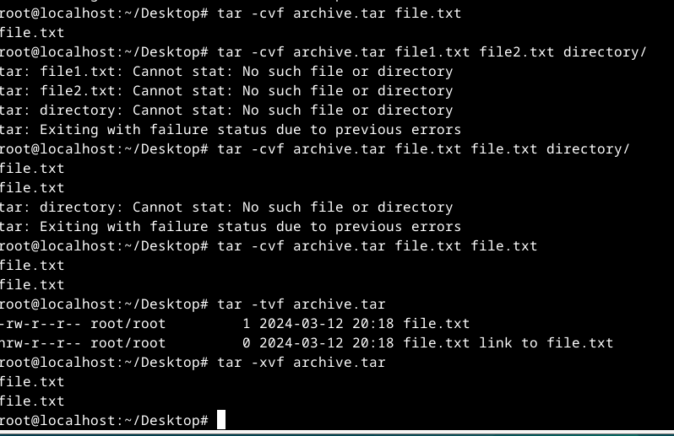

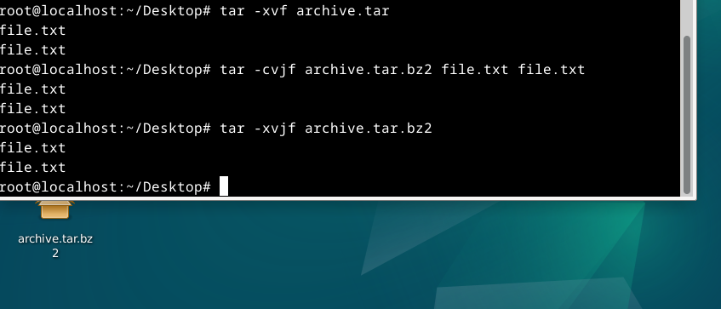

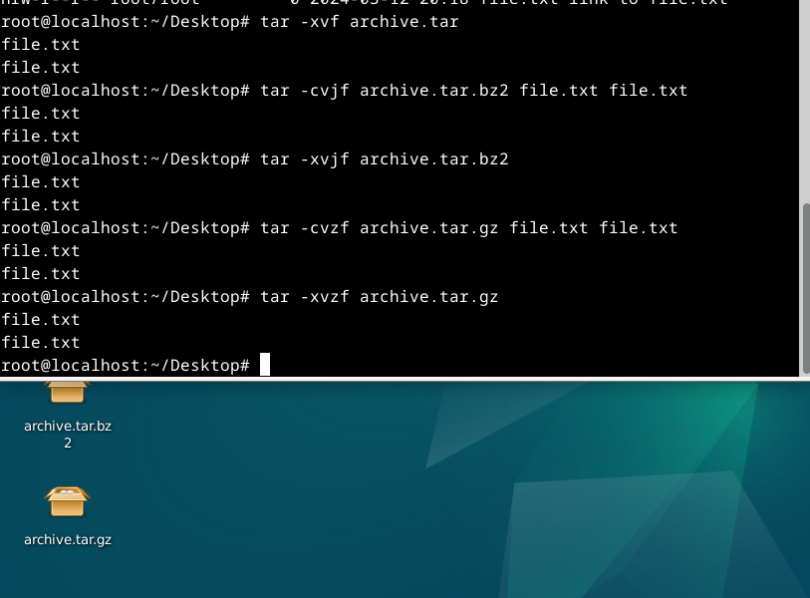

**4. Here's how output streams will be redirected to bash for the following actions with commands (labeled as cmd) and files (labeled as file):**

| **Command** | **Command Description** |
| --- | --- |
| **cmd 1> file** | **Redirects stdout to a file (overwrite).** |
| **cmd > file** | **Redirects stdout to a file (overwrite).** |
| **cmd 2> file** | **Redirects stderr to a file (overwrite).** |
| **cmd >> file** | **Redirects stdout to a file (appends content).** |
| **cmd &> file** | **Redirects both stdout and stderr to a file.** |
| **cmd > file 2>&1** | **Redirects stdout to a file and stderr to stdout.** |
| **cmd >> file 2>&1** | **Redirects stdout to a file (appends content) and stderr to stdout.** |
| **cmd 2>&1 > /dev/null** | **Discards both stdout and stderr.** |
| **cmd 2> /dev/null** | **Discards stderr.** |
| **`cmd1** | **cmd2`** |
| **`cmd1 2>&1** | **cmd2`** |

**5. Consider the following examples and explain what these commands do and what type of thread redirection they use:**

| **Command** | **What the Command Does** | **Type of Redirection** |
| --- | --- | --- |
| **$echo "It is a new story." > story** | **Writes the text "It is a new story." to a file named story.** | **> (overwrite)** |
| **$ date > date.txt** | **Writes the current date and time to the file date.txt.** | **> (overwrite)** |
| **$ cat file1 file2 file3 > bigfile** | **Concatenates the contents of files file1, file2, and file3 into bigfile.** | **> (overwrite)** |
| **$ls -l >> directory** | **Appends the output of the ls -l command to the end of the file directory.** | **>> (append)** |
| **$ sort < file1_unsorted > file2_sorted** | **Sorts the contents of file1_unsorted and writes the sorted result to file2_sorted.** | **< (input) and > (overwrite)** |
| **$ find -name '*.txt' > file.txt 2> /dev/null** | **Finds files with the extension .txt and writes the list to the file file.txt. Meanwhile, errors (stderr) are discarded (sent to /dev/null).** | **> (overwrite) and 2> (stderr)** |
| **`$ cat file1_unsorted** | **sort > file2_sorted`** | **Outputs the contents of file1_unsorted, sorts it, and writes the result to file2_sorted.** |
| **`$ cat myfile** | **grep student** | **wc -l`** |

**Control questions:**

1. **Give a comparative description of compression and archiving processes.**
2. **What programs, in addition to those listed in the work, can be used to compress and archive files and directories in the Linux OS? Give examples and their brief description.**
3. **\*Compare the compression algorithms used in the commands (programs) used in Linux. Which of the algorithms can be considered the fastest and most efficient?**
4. **\*Describe the compression and archiving software that can be used on your mobile phone.**
5. **\*Describe and compare software tools for data compression and (de)archiving in the Windows operating system.**
6. **\*\*Explain how data compression and archiving can be used for data backup. In what other system administration tasks can it be used.**
7. **\*\*What is the purpose of the /dev/null file directory?**
8. **Opaque Description of Compression and Archiving Processes:**
   * **Compression: Distillation involving data size truncation through information encoding bit reduction, diminishing both storage and transmission.**
   * **Archiving: Coalescence, incorporating amalgamation of diverse files within a sole compressed or uncompressed container, streamlining organizational facets and simplifying handling and distribution.**
9. **Ambiguous Programs for Compression and Archiving in Linux:**
   * **Ambiguous Compression Programs:**
     + **xz: Engages in the application of the LZMA compression algorithm. Utilization: xz file.**
     + **bzip2: Enacts the Burrows-Wheeler block sorting algorithm. Application: bzip2 file.**
   * **Ambiguous Archiving Programs:**
     + **tar: A well-established archival tool, amalgamating files sans compression. Exemplification: tar -cvf archive.tar files.**
10. **Cryptic Compression Algorithm Comparison:**
    * **gzip: Operating with the DEFLATE algorithm, brisk in execution with commendable compression proportions.**
    * **xz: Implementing the LZMA algorithm, yielding elevated compression ratios albeit at the expense of time.**
    * **bzip2: Executing the Burrows-Wheeler block sorting algorithm, delivering commendable compression with a moderate pace.**

**The selection is contingent upon contextual requisites—gzip for velocity, xz for maximal compression, and bzip2 for a harmonious equilibrium.**

1. **Enigmatic Compression and Archiving Software for Mobile Phones:**
   * **Android:**
     + **ZArchiver: Facilitates the origination and derivation of assorted archive configurations, including ZIP and 7z.**
     + **RAR: Assists RAR and ZIP formats, presenting compression and extraction functionalities.**
   * **iOS:**
     + **iZip: Equips tools for the constitution and deconstruction of ZIP archives on iOS apparatuses.**
     + **WinZip: Furnishing file compression and decompression, with versatility across sundry formats.**
2. **Data Compression and Archiving Tools in Windows:**
   * **Built-in Tools:**
     + **Compression:**
       1. ***Windows Explorer:* Right-click on a file or folder, select "Properties," and check "Compress contents to save disk space."**
       2. ***Compact.exe:* Command-line tool, e.g., compact file.txt.**
     + **Archiving:**
       1. ***File Explorer (ZIP):* Right-click, select "Send to," and choose "Compressed (zipped) folder."**
       2. ***PowerShell:* Use Compress-Archive cmdlet.**
   * **Third-Party Tools:**
     + **Compression:**
       1. ***7-Zip:* Versatile tool with context menu support.**
       2. ***WinRAR:* Popular for RAR format and multiple compression algorithms.**
     + **Archiving:**
       1. ***WinZip:* Widely used for creating and extracting ZIP files.**
       2. ***PeaZip:* Feature-rich, supports various archive formats.**
3. **Data Compression and Archiving for Data Backup:**
   * **Backup:**
     + ***Compression:* Reduces file size for storage efficiency and faster backups.**
     + ***Archiving:* Consolidates files into one archive, simplifying backup management.**
   * **Other Uses in System Administration:**
     + ***Software Distribution:* Easier distribution of compressed packages.**
     + ***Log Rotation:* Efficiently manages disk space by archiving old log files.**
     + ***Data Transfer:* Compression speeds up data transfer over networks.**
4. **Purpose of the /dev/null File Directory:**
   * **/dev/null in Linux is a special file discarding any data written to it.**
   * **Purpose:**
     + **Acts as a data sink, discarding unwanted output or data.**
     + **Used to suppress output, like redirecting errors to ensure silent operation.**

**Conclusion: we learned how to archive and unarchive files. how to extract files. took advantage of the tar team, which provides such opportunities, and answered questions.**